Dropout Graduation Summary Report (DGSR) User Manual

Kansas leads the world in the success of each student.

Month Year

TABLE OF CONTENTS
Table of Contents .................................................................................................................... 2
Part I: Introduction .................................................................................................................. 3
Part II: Related Documents .................................................................................................... 3
Part III: Important Terms ........................................................................................................ 3
Part IV: User Levels ................................................................................................................. 4
Part V: Registering for Access to the DGSR .......................................................................... 6
Part VI: Logging into the DGSR .............................................................................................. 8
Part VII: Quick “Tour” of the DGSR ........................................................................................ 9
Part VIII: Navigating the DGSR ............................................................................................. 10
- Post-Graduation Plans ............................................................................................... 10
- Unresolved Exits and Dropouts ................................................................................ 12
- Graduates .................................................................................................................... 16
2019-2022 Four-Year Cohort Information ............................................................. 16
2018-2022 Five-Year Cohort Information .............................................................. 18
- Historic Four-Year Cohort Information .................................................................... 20
- Historic Five-Year Cohort Information ..................................................................... 21
- Special Circumstances Remove from Cohort ......................................................... 22
- Report Sign-Off ........................................................................................................... 23
Part IX: Printing the DGSR .................................................................................................... 26

Part I: Introduction
The Dropout Graduation Summary Report (DGSR) provides all schools and districts an opportunity to review and certify their dropout and graduation data are correct before submitting the report to the Kansas State Department of Education (KSDE).

The DGSR is an online application that is accessible through the KSDE Authentication page. This report focuses on three key pieces of data:
- Post-Graduation Plans
- Dropouts and Unresolved Exits
- Graduates (four-year and five-year cohorts)

The DGSR is open from October 2nd to October 31 for 2023. Any school that does not review its data and submit the report by October 31, will by default have its data considered as accurate.

We hope that you will find the DGSR useful in certifying the accuracy of the dropouts and graduates for the recently completed school year.

Part II: Related Documents

https://www.ksde.org/Agency/Division-of-Learning-Services/Career-Standards-and-Assessment- Services/CSAS-Home/Graduation-and-Schools-of-Choice/Graduation-and-Dropouts

- Kansas Graduation and Dropout Information Handbook
- KIDS EXIT Codes Applied to Graduation Rate Formula

Part III: Important Terms

KIDS Collection System: The Kansas Individual Data on Students (KIDS) Collection System is a sophisticated software system used to manage educational data collected to meet state and federal reporting requirements. Data uploaded from your student information system to KIDS is used to populate the DGSR.

EOYA Collection: End of Year Accountability records are used to construct a complete list of students who have ever entered or left a graduating class or cohort, as defined by their ninth-grade status. These cohorts, together with all transfers in and transfers out, will be used to calculate the federally required adjusted cohort graduation rates for all students and student subgroups. For more information on KIDS Data Submission Detail EOYA, go to: http://kidsweb.ksde.org/Documents
EXIT Collection: EXIT records provide information for graduation and dropout counts and for rates calculated and used in AYP determinations. EXIT records are used to pre-populate the DGSR. Exit information (D27, D28, and D31) can only be included on EXIT record types. For more information on KIDS Data Submission Detail EXIT, go to: http://kidsweb.ksde.org/Documents

- EXIT/Withdrawal Date: Schools are required to report an EXIT/Withdrawal date of the student’s last day enrolled at the school or the date the student graduated. EXIT/Withdrawal dates are to be indicators of when a student’s affiliation with a school ended (last day of attendance), not an indication of the date a school submitted the EXIT record to KIDS.

- EXIT/Withdrawal Type: Only students with a value in D10: Current Grade Level of code 8 (eighth grade) or above may have an EXIT record with D28: Exit/Withdrawal Type of 8 – graduated with regular diploma or 22 – student with disabilities who me the district graduation requirements for a regular diploma but is remaining at school to receive transition services deemed necessary by the IEP team

- Post-Graduation Plans: The intended post-secondary direction of graduates. This field is required for all D28: EXIT/Withdrawal Type= 8 (graduate) or 22 (student with disabilities who met the district graduation requirements for a regular diploma, but is remaining in school to receive transitional services deemed necessary by the IEP team).

Part IV: User Levels

School-level access is for principals, or their designees, who are reviewing and/or submitting the DGSR for their building. District-level access is for superintendents, or their designees, who are reviewing and/or submitting the DGSR for their district. District-level users are also responsible for reviewing and submitting the DGSR for closed schools and the central office.

User Level | Defined Roles/Responsibilities
School | - Has read capability in the DGSR for the building for which he/she is responsible.  - Has submit capability in the DGSR for the building for which he/she is responsible.
District | - Has read capability in the DGSR for the district (and all of the buildings) for which he/she is responsible.  - Has submit capability in the DGSR for the district (and all of the buildings) for which he/she is responsible.

NOTE: Closed schools may show up on the DGSR if they have dropout or graduate data. The superintendent, or his/her designee, can access that building’s Dropout Graduation Summary report by clicking on the building name from the report sign-off screen. After the Superintendent reviews the building information he or she can approve the building report by clicking on the <Submit to Superintendent> button, then clicking <Return to Building List> to return to the district level report.

NEW TIP: Buildings with grades K-6 will also want to review their unresolved exit data on the
Unresolved Exit and Dropout page. Although this data is not part of the district’s dropout or graduation
calculations, it is important that correct EXIT records be submitted for all students. 4 Dropout/Graduation Summary Report User’s Guide

Part V: Registering for Access to the Dropout/Graduation Summary Report
Individuals who do not have access to KSDE web applications need to register. Please navigate to: User Login for KSDE Web Applications Once there, click on the Register button, as shown below:

NOTE: You may want to skip this section if you have used the DGSR before, or if you already registered for access to the DGSR.

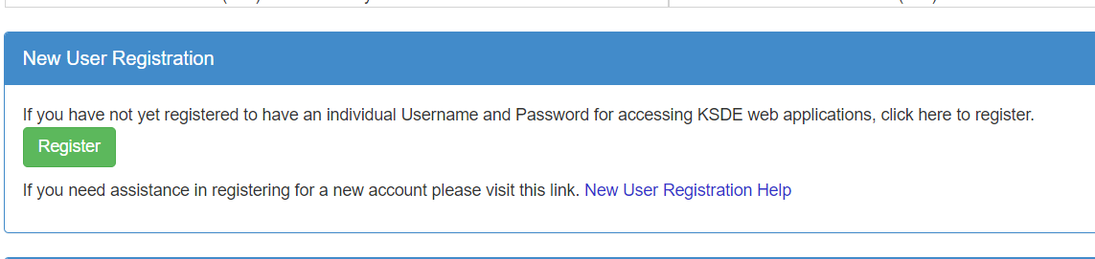

On the Registration page, enter the required information. Be aware that the buildings and districts that you have access to depend on what is displayed in the “Building” field on the web applications
registration page. For example, if you will be submitting and viewing data at the district-level, select the “All Buildings” option under the “Building” field. If you will be submitting and viewing data at the building-level, select the appropriate building.

TIP: Do not use spaces when defining your User Name login ID. When creating your password keep in mind the password requirements shown on the screen. You will need to remember the User Name ID, password, security question/answer, and birth date that you entered. KSDE does not store this information for you.

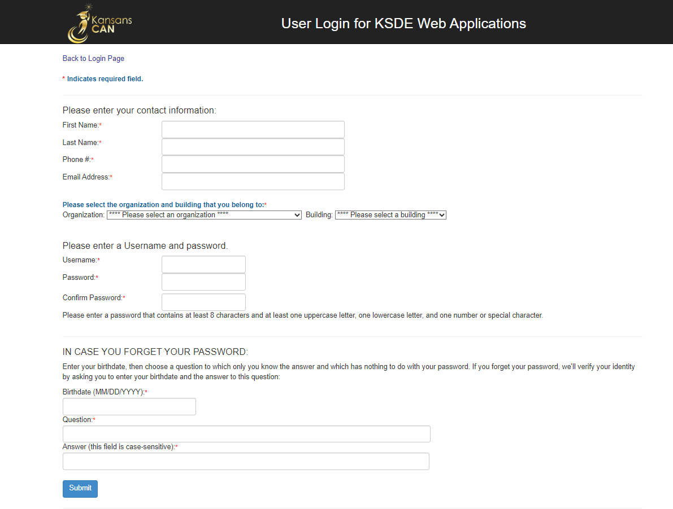
When you have completed all required information on the registration form, click the “Submit” button at the bottom of the screen.

If all data on the registration form is valid, you will get a message that says “Thank You for Registering”. The registration request will be forwarded to the district superintendent for approval. You will receive an email when your access request is approved and your username and password are ready for use.
Individuals who already have access to KSDE web applications can use the Manage My Account option
to add the DGSR to their list of applications. As with all KSDE web applications, the district superintendent will receive a request for approval before access is granted.

To add the DGSR to your list of available KSDE web applications:
- Login on the KSDE Web Applications page
- Click the “Manage My Account” link
- Check the box in front of Dropout/Graduation Summary Report
- Select your access level (school or district)
- Click “Submit”

Your request will be sent to the district superintendent for approval. When approved, you will receive an email indicating that you can access the DGSR.

TIP: If you forget your KSDE web applications password, click on the link that says “Forgot Your Password?” on the Authentication screen. You will be prompted to supply the answer to a security question (you entered it when you originally registered), type in your birth date, and enter a new password. If your security question answer and birthday match what you originally entered when you registered for KSDE web application access, then your new password will be activated. Keep in mind that KSDE does not know your password, so you are responsible for managing and remembering it.

Part VI: Logging into the Dropout Graduation Summary Report

The DGSR, like the other KSDE web applications, is available on the KSDE Authentication page. To access the DGSR, enter your username and password on the KSDE Web Application page: KSDE Web Applications. The user will see the Dropout Graduation Summary option. Notice that the manage my account and log off buttons have moved.
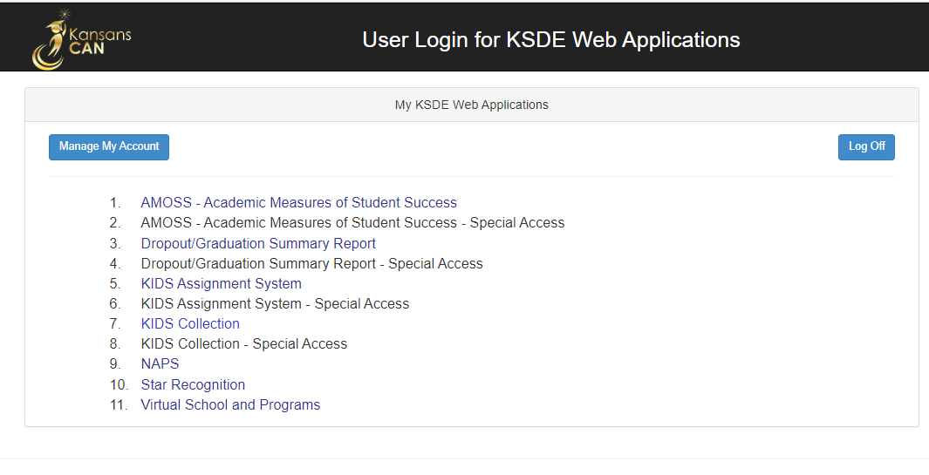

NOTE: Some of the applications may be grayed out. This means that they are either not active applications, or that you have not yet been approved for access to those applications. Additionally, the numbering of applications is unique to each individual user.

Part VII: Quick “Tour” of the Dropout Graduation Summary Report

Welcome Page
For most users, this is the first screen that will appear after entering the report. From here you will be able to begin the report, jump to a specific screen, and review some basic information about the report.

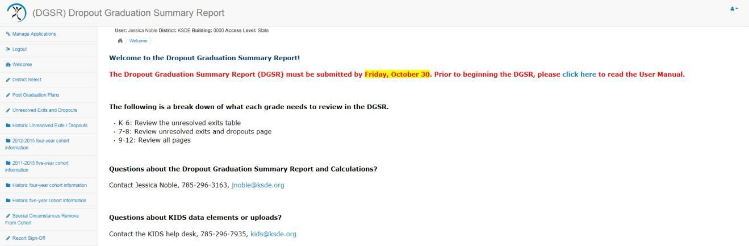

Navigation Menu
Below is the navigation menu that lists the seven links on the left side of the screen that can be used to navigate in the application:
- Post-Graduation Plans
- Unresolved Exits and Dropouts
- Historic Unresolved Exits and Dropouts
- 2020-2023 Four-Year Cohort Information
- 2019-2023 Five-Year Cohort Information
- Historic Four-Year Cohort Information
- Historic Five-Year Cohort Information
- Special Circumstances Remove from Cohort
- Report Sign-Off

Part VIII: Navigating the Dropout Graduation Summary Report

POST-GRADUATION PLANS
This section displays the D31: Post-Graduation Plans of the 2022-2023 graduating class (includes students with D28: EXIT/Withdrawal codes of 8-graduate and 22-student with disabilities who met the district graduation requirements for a regular diploma, but is remaining in school to receive transitional services deemed necessary by the IEP team). Includes graduates from four-year cohort as well as students graduating early and late in their cohort during their 2022-2023 year.
This data is disaggregated by gender, race/ethnicity, socioeconomic status, students with disabilities, English language learner (ELL), migrant, homeless, virtual, military and foster care. Please note: owing to system changes, submissions made after Augt 9 will not populate.

Post-Graduation Table 1 - Select a building to see building level 2022-2023 post-graduation data.
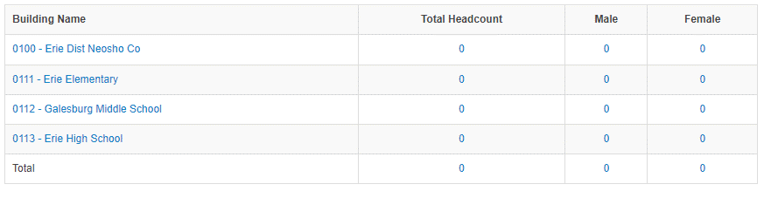

District-level staff can access building-level detail by clicking on the building name for any screen. Any school with grade 12 will have post-graduation data.

Post-Graduation Table 2 - Post-Graduation Plans by Gender (District Level)
TIP: If you click on these hyperlinks, you will be able to see a drilldown list of students included in that number. These drilldown lists can be downloaded. Use caution when downloading this information as it is personally identifiable
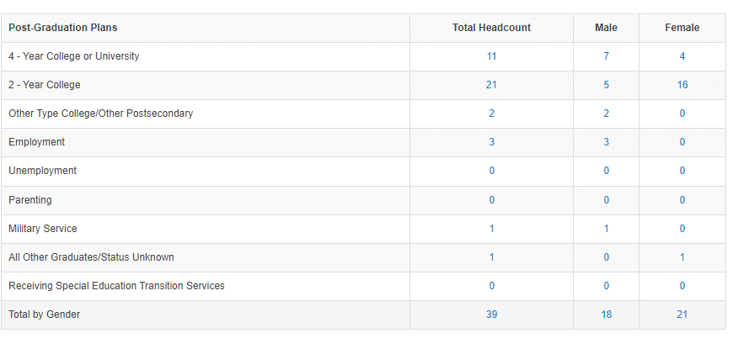

NOTE: If you notice that student information is missing (i.e. name or grade) it is because this information was not included on an EXIT or EOYA record submitted by the building.

Post-Graduation Table 3 - Post-Graduation Plans by Race/Ethnicity and Gender (District Level)
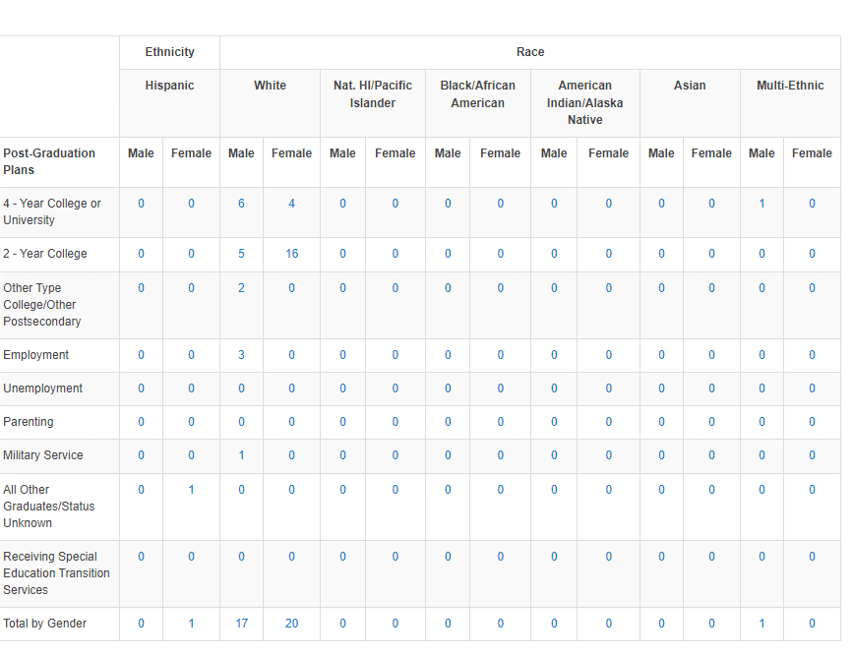

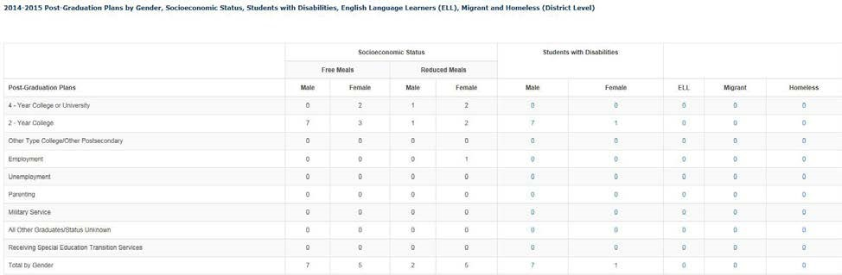
Post-Graduation Table 4 - Post-Graduation Plans by Gender, Socioeconomic Status, Students with Disabilities, English Language Learners (ELL), Migrant, Homeless, Virtual, Military and Foster Care (District Level)

Post-Graduation Table 4 - Post-Graduation Plans by Gender, Socioeconomic Status, Students with Disabilities, English Language Learners (ELL), Migrant, Homeless, Virtual, Military and Foster Care (District Level)
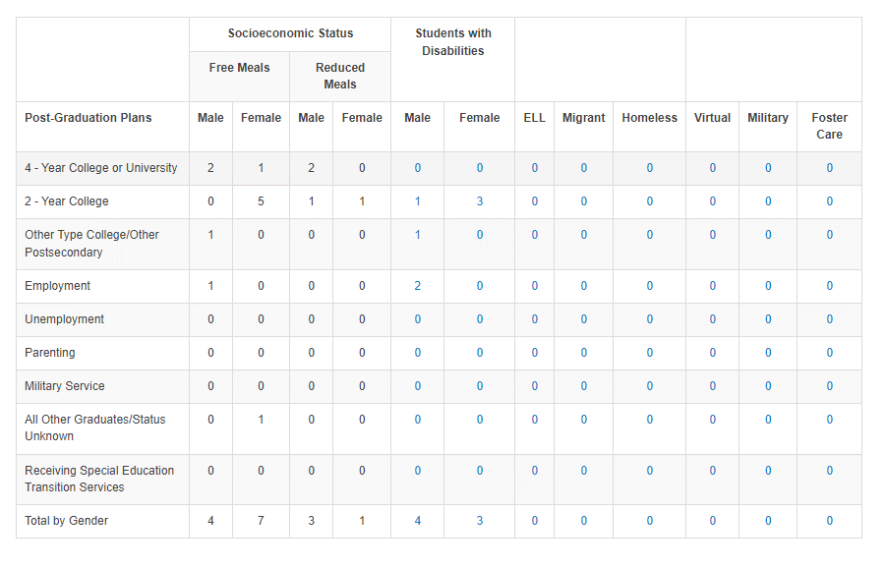

NOTE: Drilldown lists are not available for socioeconomic status, because this is federally protected information.

UNRESOLVED EXITS AND DROPOUTS

This section displays grades K-12 unresolved exits and grades 7-12 dropouts during the 2022-2023 school year. The dropout calculation is based on activity from the 2022-2023 school year only. These dropouts are not a direct match with students that are counted for or against graduation. The dropout rate is not included in Annual Measurable Objective (AMO) determination.

This data is disaggregated by building/grade, gender, race/ethnicity, socioeconomic status, students with disabilities, English language learner (ELL), migrant, homeless, virtual, military and foster care.

NOTE: Any unresolved exits in grades 7-12 are counted in the school’s and district’s dropout calculations.

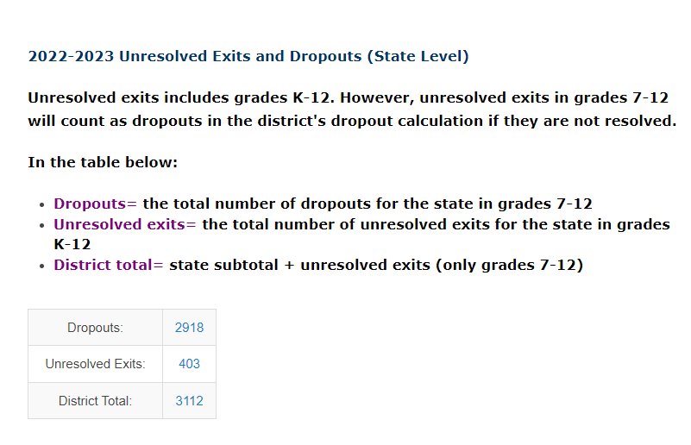
Dropouts Table 1-Unresolved Exits and Dropouts

Unresolved exit data is pre-populated based on students who:
- Are "owned" by the school in KIDS (have the school listed as the accountability school in Assignment)
- Were submitted at some point last year as part of an ENRL or EOYA record (or both) * Were not submitted on an EXIT record last year
- Have not been submitted to KIDS this year on an ENRL or ASGT record.

NOTE: If your district total does not match the number of records in the district total drilldown list, you have a student(s) with an unresolved exit from two different schools in your district.

Dropouts Table 2 - Dropouts by Building and Gender (District Level)

NOTE: Dropout data for grades 9-11 could affect future years' graduation rates. Be sure to review the data and make appropriate corrections now. The dropout tables are calculated based on activity from the school year only. These dropouts will not be a direct match with the non-graduates listed in the cohort graduation pages.

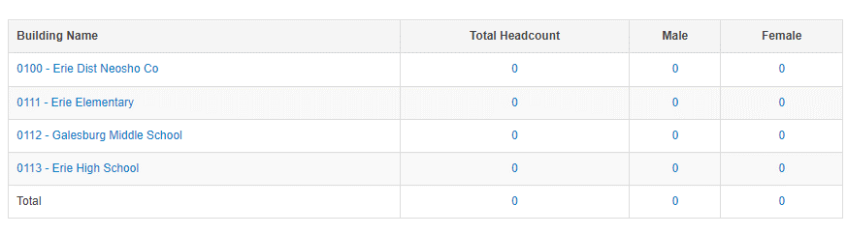

District-level staff can access building-level detail by clicking on the building name for any screen. Any school with 7-12 grade will have dropout data.

Dropouts Table 3 - Dropouts by Race/Ethnicity and Gender
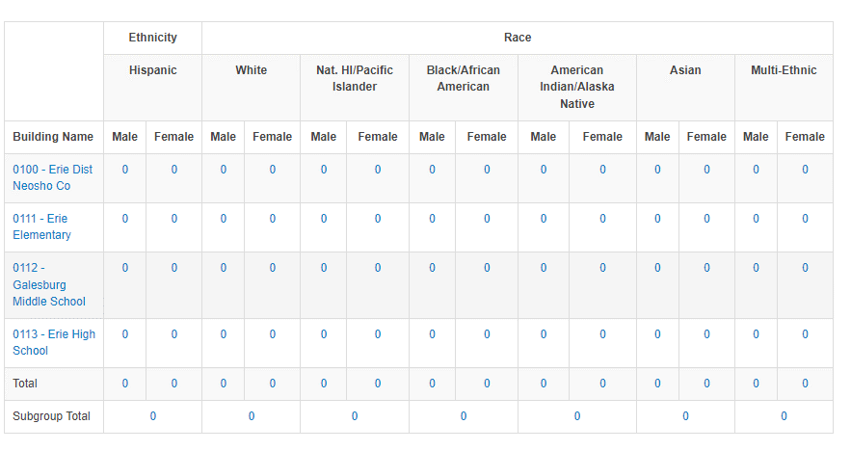
TIP: If you click on these hyperlinks, you will be able to see a drilldown list of students included in that number. These drilldown lists can be downloaded. Use caution when downloading this information as it is personally identifiable.

NOTE: If you notice that student information is missing (i.e. name or grade) it is because this information was not included on an EXIT or EOYA record submitted by the building.

Dropouts Table 4 - Dropouts by Gender, Socioeconomic Status, Students with Disabilities, English Language Learners (ELL), Migrant, Homeless, Virtual, Military and Foster Care (District Level)
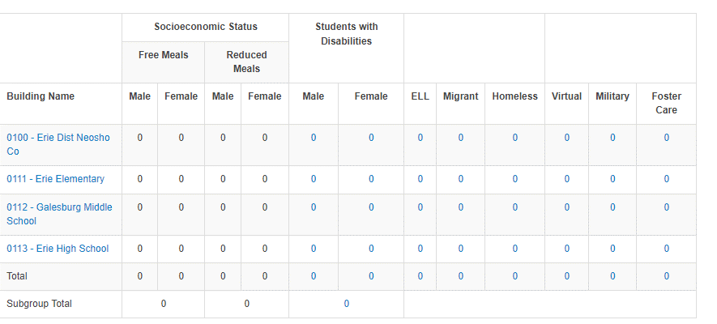

NOTE: Drilldown lists are not available for socioeconomic status, because this is federally protected information.

GRADUATES: 2020-2023 Four-Year Cohort Information

This section displays the 2020-2023 four-year adjusted cohort graduation data. This data is disaggregated by grade, gender, race/ethnicity, socioeconomic status, students with disabilities, English language learner (ELL), migrant, homeless, virtual, military and foster care.

2020-2023 Four-Year Cohort Table 1 -Building Selection

District-level staff can access building-level detail by clicking on the building name for any screen. Any school with 9-12 grade will have 2020-2023 four-year adjusted cohort data.

2020-2023 Four-Year Cohort Table 2 - Four-Year Adjusted Cohort Summary by Gender (District Level)

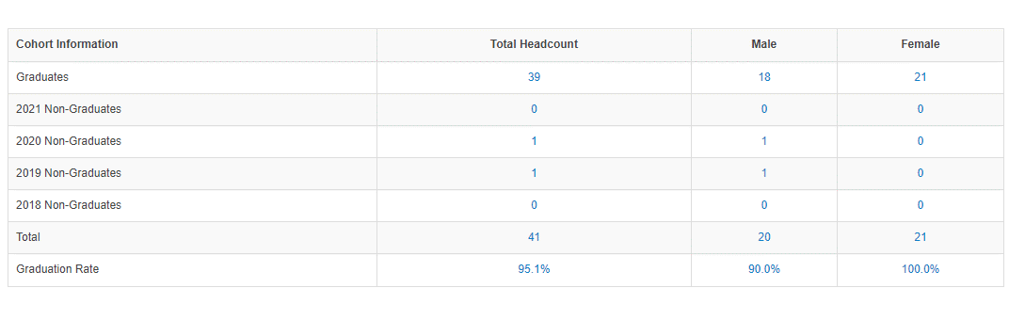

NOTE: If the sum of the graduates and non-graduates above does not match the actual total listed above this means that:
- A student was a 2023 non-graduate (exited between 7-1-22 and 9-30-23). The student is still part of the cohort, but will not appear in a 2023 non-graduate line. The student is included in the total drilldown.
- A student has been included in the cohort in error. Refer to the Special Circumstances Remove from Cohort page to see if a middle or elementary school student was included in the cohort in error.

2020-2023 Four-Year Cohort Table 3 – Cohort Summary by Race/Ethnicity and Gender
TIP: If you click on these hyperlinks, you will be able to see a drilldown list of students included in that number. These drilldown lists can be downloaded. Use caution when downloading this information as it is personally identifiable.

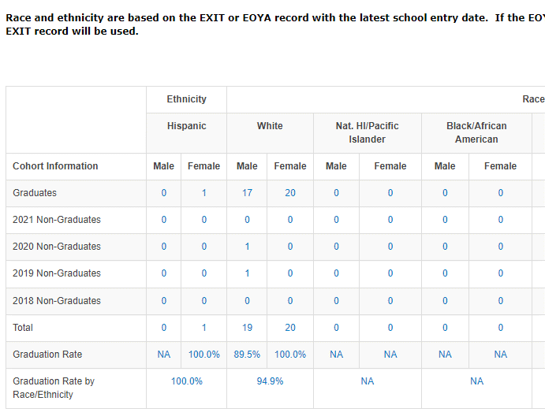

NOTE: If you notice that student information is missing (i.e. name or grade) it is because this information was not included on an EXIT or EOYA record submitted by the building.

2020-2023 Four-Year Cohort Table 4 - Four-Year Adjusted Cohort Summary by Gender, Socioeconomic Status, Students with Disabilities, English Language Learners (ELL), Migrant, Homeless, Virtual, Military and Foster Care (District Level)
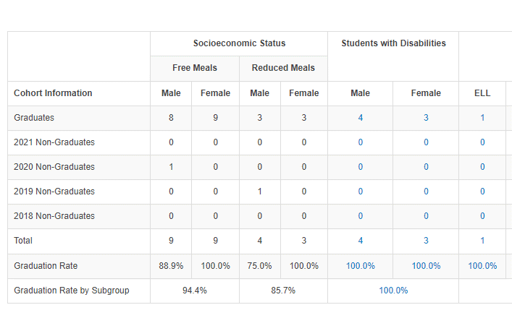

NOTE: Drilldown lists are not available for socioeconomic status, because this is federally protected information.

GRADUATES: 2019-2023 Five-Year Cohort Information

This section displays the 2019-2023 five-year adjusted cohort graduation data. This data is disaggregated by grade, gender, race/ethnicity, socioeconomic status, students with disabilities, English language learner (ELL), migrant, homeless, virtual, military and foster care.

NOTE: Corrections cannot be made to the 2019-2023 five-year adjusted cohort. This data was used for AMO determination last year and has already been reported on the KSDE website. It is displayed for information purposes only.

2019 – 2023 Five-year Cohort Table 1 - Select a building to see the building level five-year adjusted cohort report.
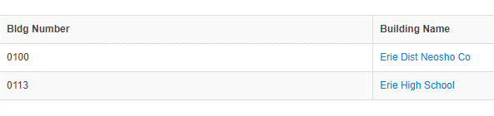

District-level staff can access building-level detail by clicking on the building name for any screen. Any school with 9-12 grade will have 2019-2023 five-year adjusted cohort data.

2019-2023 Five-Year Cohort Table 2 - Five-Year Adjusted Cohort Summary by Gender (District Level)
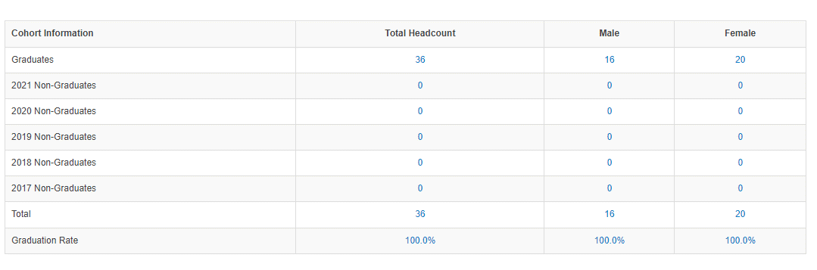

2019-2023 Five-Year Cohort Table 3 - Five-Year Adjusted Cohort Summary by
Race/Ethnicity and Gender (District Level)
TIP: If you click on these hyperlinks, you will be able to see a drilldown list of students included in that number. These drilldown lists can be downloaded. Use caution when downloading this information as it is personally identifiable.
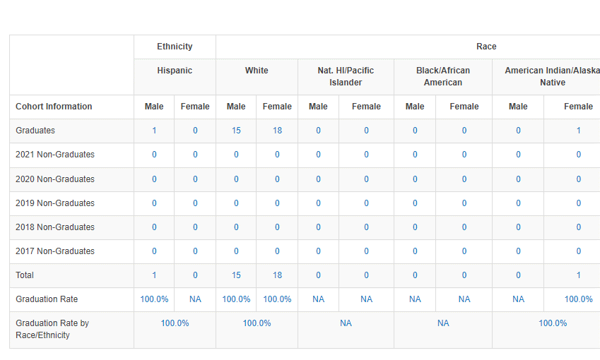

NOTE: If you notice that student information is missing (i.e. name or grade) it is because this information was not included on an EXIT or EOYA record submitted by the building.

2019-2023 Five-Year Cohort Table 4 - Five-Year Adjusted Cohort Summary by Gender, Socioeconomic Status, Students with Disabilities, English Language Learners (ELL), Migrant, Homeless, Virtual, Military and Foster Care (District Level)

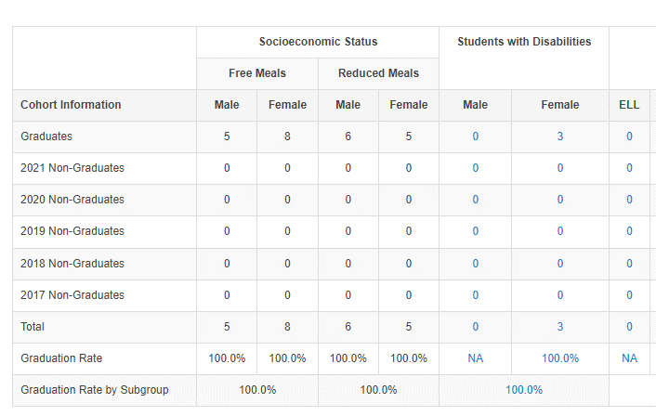

NOTE: Drilldown lists are not available for socioeconomic status, because this is federally protected information.

HISTORICAL FOUR-YEAR COHORT INFORMATION

This section displays the historical four-year adjusted cohort graduation data. This data is disaggregated by grade, gender, race/ethnicity, socioeconomic status, student with disabilities, English language learner (ELL), migrant, homeless, virtual, military and foster care.

- 2019-2022 Four Year Cohort
- 2018 -2021 Four Year Cohort
- 2017 – 2020 Four Year Cohort
- 2016-2019 Four-Year Cohort
- 2015-2018 Four- Year Cohort

NOTE: Corrections cannot be made to historical four-year adjusted cohorts. This data was already used for AYP/AMO determination and has been reported on the KSDE website. It is displayed for information purposes only.
NOTE: Virtual and Military subgroups were added in 2017-2017. Foster care subgroup was added in 2017-2019.

HISTORICAL FIVE-YEAR COHORT INFORMATION

This section displays the historical five-year adjusted cohort graduation data. This data is disaggregated by grade, gender, race/ethnicity, socioeconomic status, student with disabilities, English language learner (ELL), migrant, homeless, virtual, military and foster care.

- 2018 – 2022 Five Year Cohort
- 2017-2021 Five Year Cohort
- 2016-2020 Five-Year Cohort
- 2015-2019 Five-Year Cohort
- 2014 – 2018 Five-Year Cohort

NOTE: Corrections cannot be made to the historical five-year adjusted cohorts. This data was already used for AYP/AMO determination and has been reported on the KSDE website. It is displayed for information purposes only.
NOTE: Virtual and Military subgroups were added in 2017-2017. Foster care subgroup was added in 2017-2019.

SPECIAL CIRCUMSTANCES REMOVE FROM COHORT

Under special circumstances, buildings can remove a student from the 2022-2023 four-year cohort. Students in the 2021-2022 five-year cohort are not eligible to be removed from the cohort. These situations will be unique and will not apply to all non-graduates.

On the Special Circumstances Remove from Cohort page there are five questions to help determine eligibility for a student to be removed from the cohort. If the student meets the criteria of the five questions, then he/she is eligible to be removed from the cohort. Buildings should follow the process below:

NOTE: The student is simply eligible for removal from the cohort. Actual removal from the cohort requires further KSDE approval.
- Select the student from the list
- Select a removal reason
- Add a comment FULLY explaining the student's situation and describing the documentation available
- Add an email address
- Click "insert" to send the request to KSDE
- Be sure to check back on the DGSR in case more information is needed by KSDE to process the request.
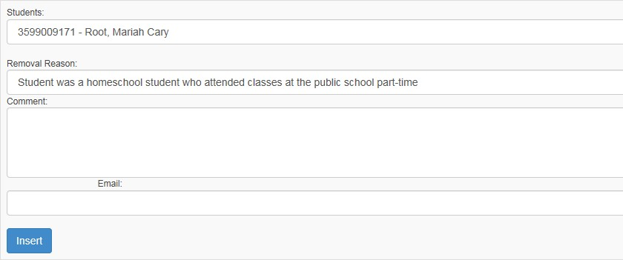

NOTE: Buildings no longer need to send KSDE a detailed email. Instead the information should be included in the comment box.

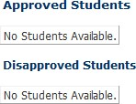
KSDE staff will then evaluate the student’s situation and make a determination whether to remove the student from the cohort. Once this is complete, the student will show up in the Approved Students or Disapproved Students lists.

REPORT SIGN-OFF

Building Administrators

All accredited buildings (public and private) must login to the DGSR to certify the unresolved exits, dropouts and graduate totals for the previously completed school year are accurate.

By submitting this report, you are agreeing the data is accurate. You will not have an opportunity to correct this data after the submission window has closed. This affects dropout and graduation calculations that are reported for your building.

IMPORTANT: You must submit the report even if you have zero unresolved exits and dropouts for your building.

After navigating through each screen, your last screen will be the Report Sign-off screen. To electronically certify the data is accurate, you must click the <Submit to Superintendent> button. When you click this button, it will lock the data and notify the Superintendent you have approved your data, thus allowing him/her to sign-off at the district level.
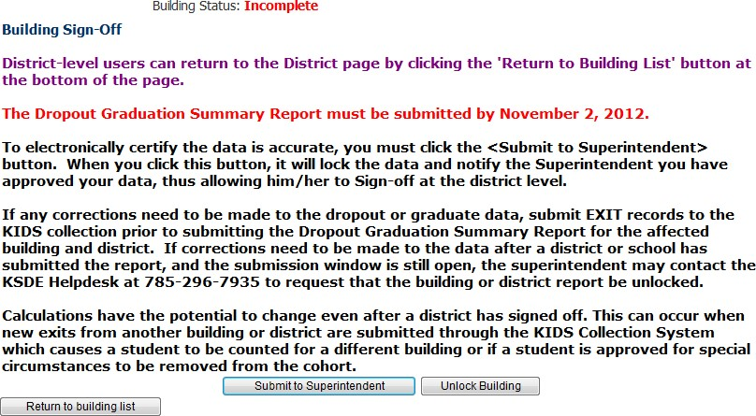

After submitting to Superintendent,

the

building status will change to

Complete

If the Dropout/Graduation Summary Report for the building is Complete [Submitted to Superintendent] and you realize changes need to be made to the data, you may call the KSDE Help Desk at 785-296-7935 to have the report unlocked. This can only be done while the submission window is open [i.e. before October 31.]
District Administrators

After each principal has certified the dropout and graduation data is accurate for the previously completed school year by <Submitting to Superintendent> on the Building Sign-off screen, superintendents will be required to submit each of their building’s data to KSDE. For each building that has a checkmark in the Bldg. Sign Off column, you should select the building to confirm you are in agreement with the totals prior to placing a checkmark in the District Sign-off column and <Submit> to KSDE.
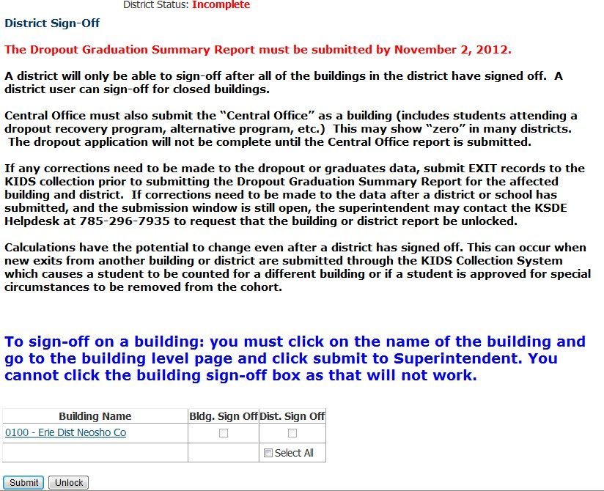

Superintendent is required to sign off on
each building, including Central Office.
NOTE: If the Principal has not signed off for a building, the superintendent can access that building’s
Dropout/Graduation Summary report by clicking on the building name from this screen. After the Superintendent reviews the building information he or she can approve the building report by clicking on the <Submit to Superintendent> button, then clicking <Return to Building List> to return to the district level report.

IMPORTANT: Central Office must also submit the “Central Office” as a building (includes adult students) This may show “zero” in many districts. The dropout application will not be complete until the Central Office report is submitted.
*If the Dropout/Graduation Summary Report for the district is Complete [Submitted to KSDE] and changes need to be made to the data, you may call the KSDE Help Desk at 785-296-7935 to have the report unlocked. This can only be done while the submission window is open (i.e. before October 31).

Part IX: Printing the Dropout/Graduation Summary Report
In order to print, you will need to print each screen directly from the web browser.

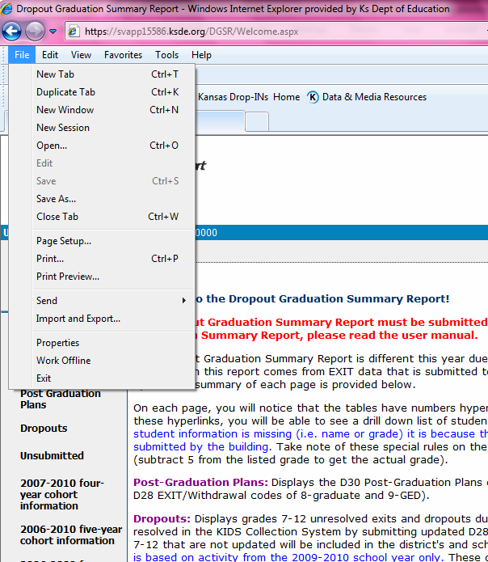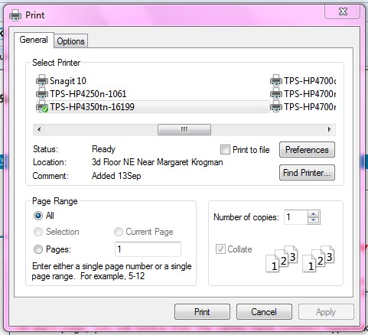

From the browser, click “File”,
then select “Print”.

A popup message will appear.

Click “Print” button to send to your
printer. This will need to be
repeated for each screen that
needs to be printed.

NOTE: Depending upon your browser, you may want to select the PRINT PREVIEW function and use the Shrink to Fit adjustment to allow each screen to print on a single page.

For more information, contact:

DGSR Helpdesk
dgsrhelpdesk@ksde.org
785-296-3444

Dr. David Fernkopf  Assistant Director  Career, Standards, and Assessment Services  785-296-8447  dfernkopf@ksde.org  Dr. Robyn Kelso  Education Program Consultant  785-296-3444  rkelso@ksde.org |  | Kansas State Department of Education  900 S.W. Jackson Street, Suite 102  Topeka, Kansas 66612-1212  www.ksde.org

